Autonomous Agent Builder Training Guide
1. Overview
This training guide walks you through building an autonomous agent end to end: defining the use case, adding actions and knowledge, writing effective instructions, configuring triggers, testing, publishing, and troubleshooting common limitations.

2. Prerequisites
- Access to your agent-building environment (e.g., Copilot Studio) with permission to create/edit agents.
- Maker credentials for any connectors you plan to use (email, Dataverse, ServiceNow, etc.).
- Optional: Power Automate access to edit triggers, tailor payloads, and implement workarounds.
- Optional: a defined knowledgebase (documents) and confirmation of whether sources require end-user authentication.

3. Step-by-step: Build your autonomous agent

Step 1 — Define the use case and success criteria
- Write the outcome statement: “The agent helps [user] accomplish [task] by [doing X].”
- Define inputs the agent can reasonably obtain (from the user, trigger payloads, actions, or knowledge sources).
- Define outputs: what the agent must produce (email, record created, summary, ticket, etc.).
- List constraints: e.g., “don’t ask the user for any details,” business rules, compliance constraints.

Step 2 — Select and set up actions (keep it lean)
- Add only the actions you need for the use case (recommendation: ≤10–15 total). Too many actions can make the agent unstable.
- Name actions clearly so the agent can choose correctly (e.g., “Purchase Order (Create)”, “Customer Booking History (Get)”).
- Verify outputs: confirm output parameters are configured and visible (e.g., “List Records” should return a “Result” output; set output mode to “All” if needed).
- Handle dynamic parameters: for CRUD actions whose fields change by record type, manually set a fixed record/entity in the action inputs and configure the relevant parameters.

Step 3 — Write primary instructions the agent can follow
Use actionable language. Prefer verbs like retrieve, get, use, analyze, extract for data work; include, exclude, identify, compare for filtering; and notify, ask, assign for outcomes.
- Be explicit about which action to run, especially when you have more than ~5 actions (e.g., “When the user provides laptop details, create a purchase order using the ‘Purchase Order’ action.”).
- Use numbered steps when order matters and state that steps must be followed sequentially.
- State interaction rules if needed (e.g., “Don’t ask the user for any details.”).
- Use topics for highly specific responses where you want strict, deterministic behavior for certain phrases.

Primary instruction template (copy/paste)
Goal: [What success looks like]
Process (follow in order):
1) Retrieve [data] using [Action/Knowledge].
2) Analyze/extract [fields].
3) If [condition], then [do X] using [specific action].
4) Create/update [record] using [specific action].
5) Notify [who] with [format requirements].
Constraints: [Don’t ask user… / include/exclude rules / compliance]

Step 4 — Fill in action descriptions (this improves action selection)
- When to call: add a one-sentence rule (e.g., “Call this action when the user asks to retrieve the customer booking history.”).
- Inputs: specify required fields and examples, especially for dates/times (include a sample format you want).
- Outputs: mention the key output fields the agent should read (e.g., “Use the Result array and extract the booking dates.”).
- Formatting requirements: if the action sends email, state “use rich text formatting for the email body.”

Action description template (copy/paste)
Call this action when: [trigger/intent]
Inputs required: [field list + examples]
Date/time format examples: [e.g., 2026-03-24 14:30]
What to do with outputs: [which output fields to read and how to use them]
Notes/constraints: [anything to avoid]

Step 5 — Add and use knowledge sources (if applicable)
- Add your knowledge sources (documents, pages, etc.).
- Name the specific documents to search in your primary instructions when you have many sources (e.g., “Search your knowledgebase for the employee onboarding document.”).
- Know the trigger limitation: sources that require an authentication token (e.g., SharePoint, Dataverse, Graph connectors, AI Builder prompts) may not work as expected when the agent is invoked via a trigger because triggers run with maker credentials and don’t request end-user auth.

Step 6 — Add triggers (optional) and design safe payloads
- Add the trigger for your event (email received, record created, schedule, etc.).
- Tailor the payload (often via Power Automate): send only what the agent needs (e.g., subject + key fields instead of an entire email object).
- Add trigger-specific instructions that tell the agent how to interpret the payload (example: “Onboard the following employee:” followed by structured details).
- Avoid terms that may be blocked by content filtering (for example, be cautious using words like “execute” in trigger messages).
- Edit triggers in Power Automate after creation (you can’t edit them directly in the agent builder).
- Use multiple triggers if you have distinct use cases; each trigger can have its own instructions.

Trigger payload template (copy/paste)
Instruction header: [What to do]
Data:
- Field1: …
- Field2: …
- Field3: …
Constraints: [don’t ask user / required formats]

Step 7 — Test, publish, and monitor
- Test common scenarios (happy path + edge cases) and refine instructions/action descriptions.
- Test triggers: run the triggering event once, then use the “test trigger” option to select a payload and replay it in the test pane as many times as needed.
- Publish the agent before expecting triggers to fire in real usage.
- Monitor activity: be aware that some interaction types may not appear in Activity history (for example, only maker interactions may be captured depending on current platform behavior).
- Control trigger frequency: overly frequent recurring triggers can consume resources and push the agent toward service quota limits.

4. Troubleshooting (common symptoms → fixes)
Symptom | Likely cause / fix
Trigger fires, but agent doesn’t react (no record in Activity) | Message may be blocked by content filtering. Simplify wording and avoid terms like “execute”. Also confirm the agent is published.
Can’t edit trigger settings in the agent builder | Edit the trigger in Power Automate after creation.
SharePoint/Dataverse/Graph knowledge doesn’t work when invoked by trigger | Triggers may not provide the auth token required for these sources; triggers typically run with maker credentials and don’t request end-user auth. Use an alternative design (e.g., Power Automate to fetch data and pass it in the payload).
Power Automate wraps an action in a “for each” loop and the agent fails to process it | Create a variable in the flow, move the loop to build the variable, then send the variable as the trigger payload.
Action returns no outputs | Check output parameter configuration; open the Outputs tab to refresh; set output mode to “All” where applicable.
Outlook “Create Event” doesn’t work reliably | Agent may not populate date/time fields correctly; use a Power Automate flow to create the event instead.
Agent becomes unstable as you add actions | Reduce action count (target ≤10–15) and tighten instructions/action descriptions.
CRUD action fails when record type changes required fields | Manually pin/set dynamic fields in the action inputs (e.g., set entity to Lead) and configure parameters explicitly.
Power Automate action prompts end users to authenticate | In the flow’s “Run only users” settings, choose “Use an already provided connection” to use the maker connection.
Recurring trigger causes quota/resource issues | Increase interval, add filtering before invoking the agent, and avoid high-frequency runs during testing.

5. Sharing and governance notes
- Sharing: you can share your agent with other users, but be aware that trigger credentials may be shared as well.
- Review tab: use it to inspect the agent’s reasoning/thought process during testing.
- Safety: keep trigger payloads minimal and business-focused to reduce filtering risk and accidental data exposure.
Contents
Generating Instructions 1
What kind of language should I use for writing instructions? 1
How can I ensure my agent performs specific actions? 2
Should I use the action description field, and if so, what should I include? 2
How should I structure my instructions? 2
How do I get my agent to use its knowledgebase? 3
How can I apply formatting to emails sent by my agent? 3
Using Triggers 3
Can I modify the default payload of a trigger? 3
How can I ensure that my agent reacts as expected to my trigger? 4
Can I add multiple triggers to my agent? 4
Do I need to publish my agent for the triggers to fire? 4
Can I test triggers before publishing? 4
Limitations and Workarounds 4
Why can't my agent use the Outlook ‘Create Event’ connector? 4
Why is my action not producing any output values? 4
Why are interactions with end users not showing up under ‘Activity’? 5
Why don’t knowledge sources like SharePoint work with triggers? 5
Can I edit triggers directly in Copilot Studio? 5
What should I do if Power Automate wraps a ‘for each’ loop around an action? 5
My trigger is firing and sending a message to my agent, but the agent is not reacting. Why is this? 6
Can I share my agent with other users? 6
The more actions I add, the more unstable my agent becomes. Why is this? 6
My agent fails to call certain crud operations. Why is this? 6
What is the purpose of the review tab? 7
I have created a Power Automate flow but it keeps asking the end user to connect with their credentials. Why is this? 7
How often should my trigger run? 7
How can I get my actions to format dates? 8

Appendix A: FAQ (reference)
What kind of language should I use for writing instructions?
You should use actionable language when writing instructions for your agent. Use verbs like ‘get’ and ‘use’ for retrieving and parsing data, and verbs like ‘from’ and ‘with’ for actioning on the results.
Here are some other common verbs used to create simple instructions:

Conditions
- When
- If
- Ensure
- Compare

Filter
- From
- Include
- Exclude
- Compare
- Identify

Data
- Provide
- Retrieve
- Get
- Use
- Analyze
- Extract
Actions
- Notify
- Direct
- Ask
- Assign

How can I ensure my agent performs specific actions?
Your agent will generally succeed at selecting the right action to take, but it helps to be explicit in your instructions. This is particularly helpful when there are more than five actions added to the agent. For example, if you want your agent to create a purchase order record in Dataverse using the ‘create order’ action, clearly state this in the instructions: “When the user has provided details of their preferred laptop, create a purchase order using the ‘Purchase Order’ action.”
If you want your agent to be very specific in its response to certain user inputs, then you can create a topic to handle those particular use cases. For example, “Create a topic that recognizes phrases similar to ‘have you got any other options available’ and responds very specifically that ‘No other options are currently available, please select from the available list’.”
Also, if you don’t want your agent to reach out to the end user, then explicitly state this in the instructions. For example, “Don’t ask the user for any details”.

Should I use the action description field, and if so, what should I include?
Yes, you should use the action description field because it helps your agent to choose the right action. Simply add instructions for when the agent should call a specific action, like “Call this action when the user asks to retrieve the customer booking history.”

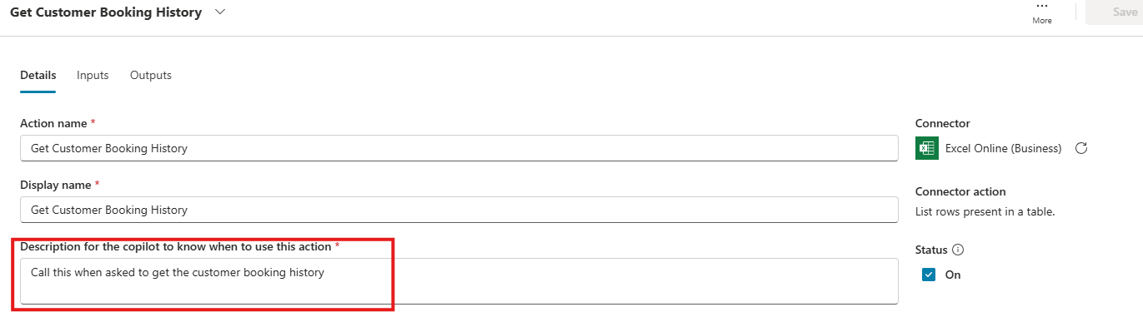

How should I structure my instructions?
If you want your agent to follow your instructions sequentially, then add numbers or bullets and specify that it must be followed in order.
You can also apply markdown format to improve the readability of your instructions and help the LLM to understand and process them.

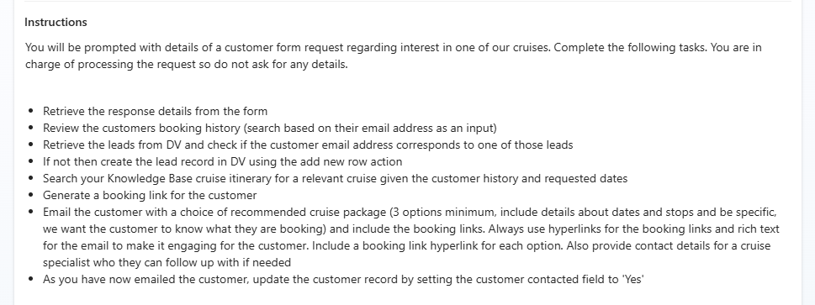

How do I get my agent to use its knowledgebase?
While this isn’t strictly necessary, it can be helpful to explain in the instructions which documents the agent should look for. This will ensure it successfully retrieves the correct information, especially if there are numerous documents that need to be searched. For example, "Search your knowledgebase for the employee onboarding document”.

How can I apply formatting to emails sent by my agent?
You can instruct your agent to "send emails using rich text formatting for the email body content" or use other similar wording. This can also be added to the action description for extra emphasis.

A2. Using Triggers

Can I modify the default payload of a trigger?
Yes, you can modify the payload and use variables to reduce the size of the payload. For example, you could send only the subject field of a received email rather than the entire message payload. Just create the trigger and then edit it via Power Automate to select specific variables.

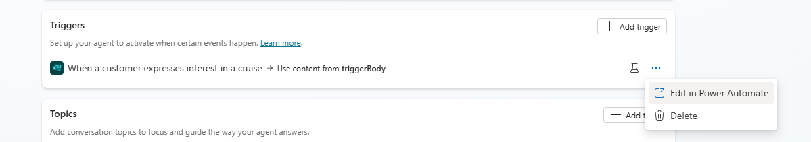
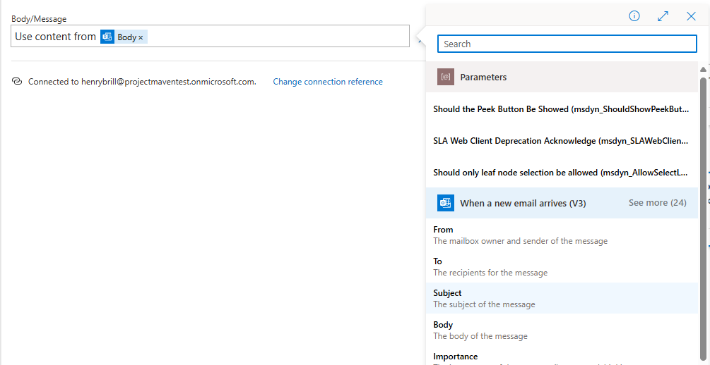

How can I ensure that my agent reacts as expected to my trigger?
You can include trigger instructions to guide the agent on how to handle the trigger payload. For instance, if your agent helps onboard new employees, you could define the trigger payload as 'Onboard the following employee' followed by the details of the new employee in the body of the trigger.

Can I add multiple triggers to my agent?
Yes, you can add multiple triggers that each have their own instructions. These triggers can supplement your primary instructions or be applied to separate use cases within the same agent, such as managing incident reports or budget requests.

Do I need to publish my agent for the triggers to fire?
Yes, your agent needs to be published for it to react to the trigger event. Once it’s published and the trigger fires, you will be able to track the interaction via the activity tab.

Can I test triggers before publishing?
Yes, you can test a trigger by running the triggering event once and then clicking on the ‘test trigger’ button located beside the trigger on the Overview tab. You’ll be able to select the payload and test it via the test pane as many times as you’d like.

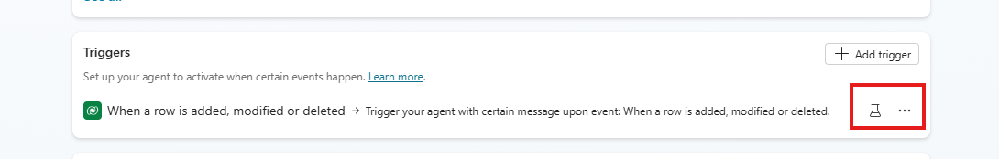
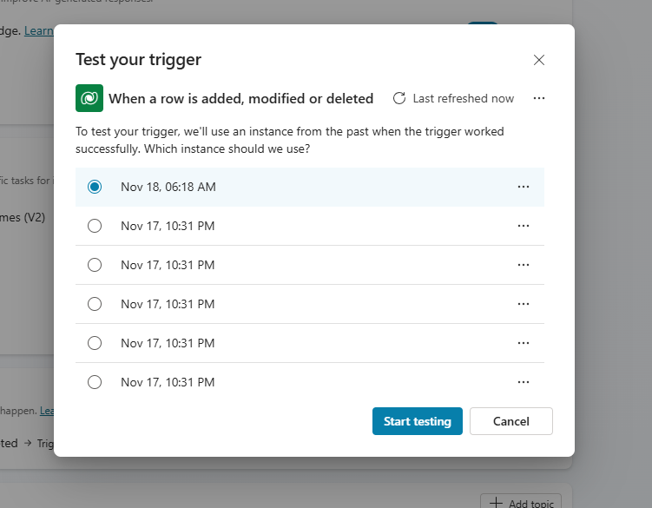

A3. Limitations and Workarounds

Why can't my agent use the Outlook ‘Create Event’ connector?
The agent is currently unable to accurately populate the date and time fields required by this connector. Instead, you can create a Power Automate flow that calls this action.

Why is my action not producing any output values?
First, you should ensure the output parameters are set correctly for the action. For example, ‘List Records’ in ServiceNow should produce an output called ‘Result.’ Occasionally, these parameters don’t immediately appear in the Outputs tab so you may need to click into the tab to see them. You may also need to set the output mode to ‘All’ to ensure values are returned.

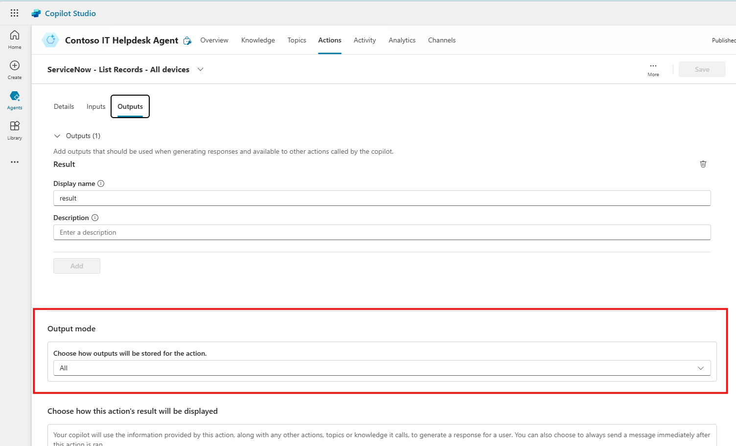

Why are interactions with end users not showing up under ‘Activity’?
Only interactions with the maker are captured in the activity history – no C2 interactions are currently recorded.

Why don’t knowledge sources like SharePoint work with triggers?
SharePoint requires an authentication token that cannot be provided when a trigger is used. Currently, triggers only utilize maker credentials and do not explicitly request end-user authentication. This also applies to Dataverse, Graph connectors, and AI Builder Prompts.

Can I edit triggers directly in Copilot Studio?
No, you can’t edit triggers directly in Copilot Studio. After they’ve been created, you must edit them via Power Automate.



What should I do if Power Automate wraps a ‘for each’ loop around an action?
This may prevent the trigger from being processed correctly by your agent. To resolve, create a variable in your Power Automate flow and wrap the ‘for each’ loop around this variable. Then, send the variable as the payload to your trigger.

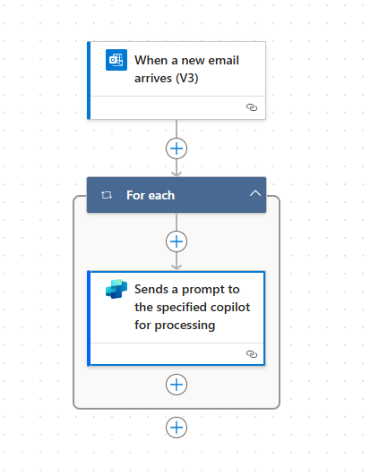

My trigger is firing and sending a message to my agent, but the agent is not reacting. Why is this?
Responsible AI content filtering may sometimes block a message, leaving no record in the activity history. Be careful using terms like ‘execute’ when defining triggers as this can cause the message to be filtered and not reach your agent.

Can I share my agent with other users?
Yes, you can. However, it’s important to note that the trigger credentials will also be shared when doing so.

The more actions I add, the more unstable my agent becomes. Why is this?
Typically, you should not add more than 10-15 actions. Adding more actions will increase the instruction set and information sent to the agent, which can cause some instability.

My agent fails to call certain crud operations. Why is this?
Actions with dynamic parameters will require special attention. For example, consider an action like ‘update record’ in an external system. The fields required may change depending on the record you select, e.g. the fields for ‘lead’ will be different to ‘opportunity’. In this case, manually set the values of dynamic fields using the action’s inputs tab. For the example shared above, you would set the record to ‘Lead’ and then configure the relevant parameters.

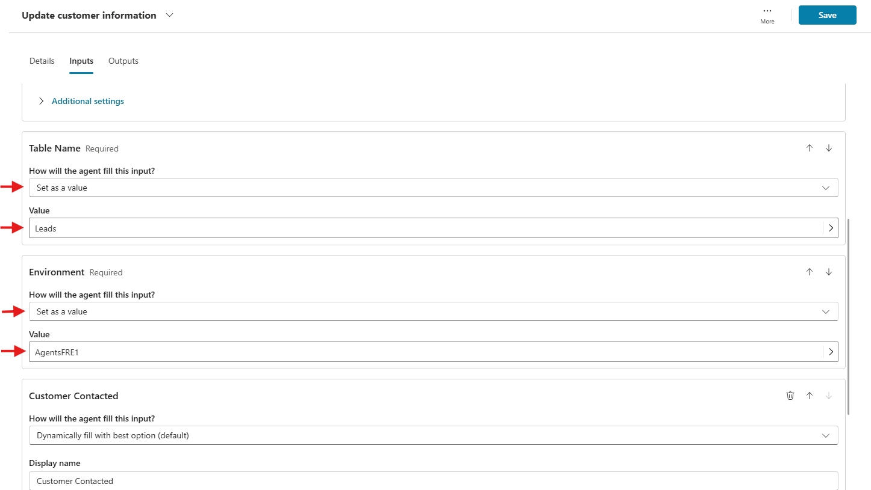

What is the purpose of the review tab?
The review tab is intended to capture the thought process of the agent.

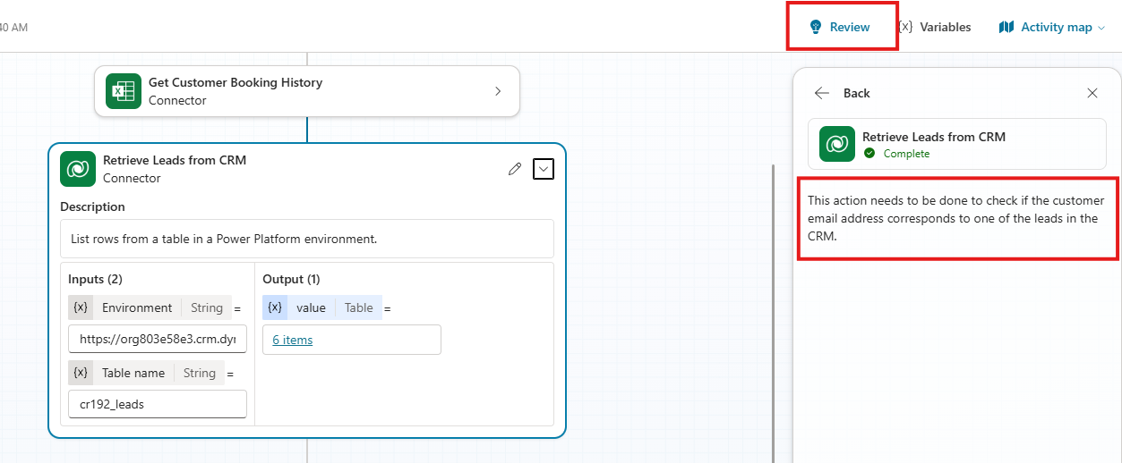

I have created a Power Automate flow but it keeps asking the end user to connect with their credentials. Why is this?
By default, if you create a flow as an action that uses a connector, it will ask the end user for their credentials. However, you can change the default to use the maker’s credentials instead. Just click into the flow via power edit, find the ‘Run only users’ setting, click on ‘Edit’ and set to ‘Use an already provided connection’.


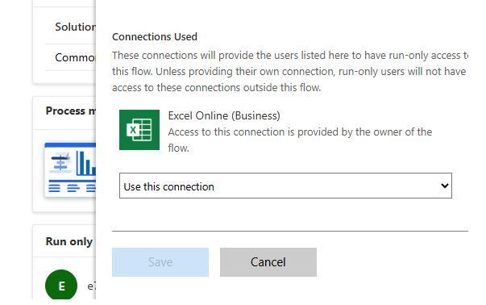

How often should my trigger run?
It depends on your use case, but frequent trigger activation can lead to higher resource usage. This may cause your agent to exceed service load quota limits. Be cautious with recurring triggers, even during testing, as they can consume significant resources if they run too often.

How can I get my actions to format dates?
Provide examples of how you want dates to be formatted in the action’s input description. For example:

